SECTION A (85 marks) answers

a) (i) 624187 (+/-1) (2 marks)
(ii) Contours
Trigonometrical station

(1 mark)
b) (i)
5.25 km

(3 marks)
(ii)
Farming
Settlement
Transportation

(1 mark)
c)
154˚ (+/- 1)

(3 marks)

d) (i)
Number of full squares = 7 1 mark
Number of half squares = 22 1 mark
Converting half squares to full squares = 22/2 = 11 1 mark
Total squares = 7 + 11 = 18 1 mark
Area = 18 x 1km x 1 km
= 18km² 1 mark
(ii) Nucleated/ clustered / compacted (1 mark)
(iii) Knoll (1 mark)
e)
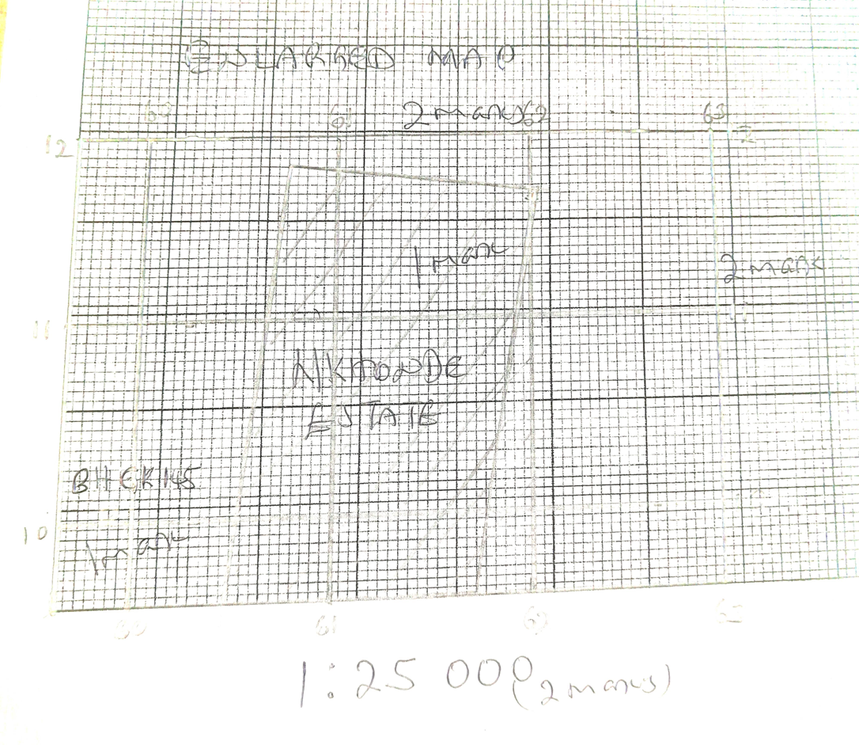

2. a. (i) Contninental plates
Oceanic plates (2 marks)
(ii)
Formed as a result of collision of the Pacific plate and the Philippine plate¹ leading to the subduction of the Pacific plate beneath the Philippine plate which created a deep furrow on the oceanic floor¹ called Mariana trench

(2 marks)
(iii) Provides beautiful scenery that attracts tourists
Contains water bodies which provides different fish species which support fishing industry
Slopes contains trees the provide valuable timber
Plain areas contain fertile soils which are good for agricultural production
Contains mineral deposits which encourage mining activities

(2 marks)
(iv) Provide natural protection against flooding
- Delays the onset of floods

(1 mark)
b) (i)

formed as a result of cooling and solidification of molten material over the earth’s surface (2 marks)
(ii)
A) Gneiss

Granite (1 mark)

B) Graphite
Coal (1 mark)
d)
A) Zone of subduction
A region where a heavier oceanic plate is forced to bend beneath another into the earth’s mantle

(2 marks)
B) Sea Floor Spreading
The process in which the ocean floor is widened when molten material from the earth’s mantle rises up at ocean ridges to create new crust

(2 marks)
e) (i)
because it is associated with collisional plate boundary which lead to crustal fold and uplifting of the crust

(2 marks)
(iii)
- Geysers
Are fountains of hot water and superheated steam periodically shooting out of the ground in a spectacular eruption
(2 marks)

- Fumeroles
Are holes on volcanic areas from which steam and hot gases are released
(2 marks)
f.
formation of fertile soils from ashes which enriches the soil with nutrients boosting agricultural production
formation of land masses for settlement and other activities
provide resources for geothermal energy extraction
create beautiful landscape which attracts tourists
creates areas rich in mineral resources
formation of lava dammed lakes that are important for fishing

(4 marks)
3. a.(i) Clastic or mechanically formed
Organically formed
Chemically formed
(2 marks)
(ii) .
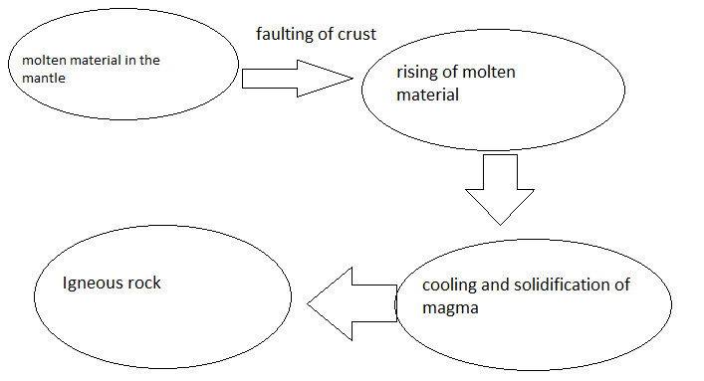

(4 marks)
b.
Forces of tension¹ causes the stretching or moving apart of the crust,¹ one block moves forward and downwards¹ (3 marks)
c. Are great in length and height
Associated with volcanism
Found on the margins of continents
Have pointed peaks and rugged features
Mostly made up of sedimentary rocks
Rich in mineral deposits
(4 marks)

d
Act as habitats to animals
Act as water retention sites and used in dry season
Helps in controlling floods by capturing floodwater
(4 marks)
e (i).Arcuate delta (1 mark)
(ii) Water with uniform or even wave action¹ arrive perpendicular to the shore with minimal long-shore current¹. Waves push back sediments creating a smooth coastline cut by distibutaries¹
(3 marks)
f. 1. Earthquakes
Faults creates sites of weakness through which pressure is released causing earthquakes which lead to great destructions of property and loss of life
- marks)
2. Drought
Faulting create block mountains which have rain shadow areas which experience little or no rainfall
(2 marks)

SECTION B
(25 MARKS)
Answer only ONE question in this section
4. a) (i) Is the gradual movement of the continents across the earth’s surface through geologic time
(1 mark)
(ii) A) fit of Southern continents
Matching of continents of Africa, South America, Antarctica etc into one complete structure show that they were once together

(2 marks)

B) Similarity of rock sequence of the continents
Rock layers of eastern Brail and western coast of Africa where the continental coast match show similar pattern and structure showing that they were one together
(2 marks)
b) (i) Earthquakes and tremors which destroy property and loss of life
Little of no rainfall due to existence of rain shadow areas
Poor means of transport as a result of steep escarpments which hinder development of communication and transport systems
Landslides which destroy properties (4 marks)
- Have a steep and small slope on the fault scarp but a long and gentle slope wy
Have nearly flat or gently sloping tops
Are usually long
Are associated with the rift valleys
(4 marks)
- (i)
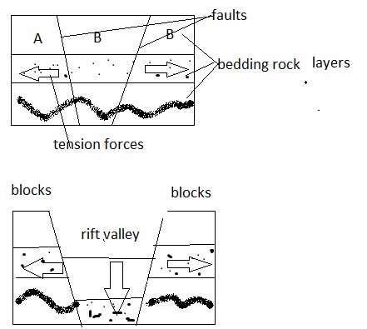 faults 1 mark
Forces 1 mark
Rift valley 1 mark
Blocks 1 mark
(4 marks)
Forces of tension¹ act on earth crust forming parallel faults¹ forming three blocks (a, b and c)
The forces move outwards forcing the middle block (b) to sink¹ and out blocks (a and c) to hang up. The sunken block create a rift valley¹
(4 marks)
- (i) Is the eruption of magma and volatile material to the surface from the interior of the earth

(1 mark)
(ii) Usually occur in isolation
Conical in shape
Are symmetrical (4 marks)
5. a) (i) Is a collection of facts, often, numerical, from which new knowledge may be derived
(1 mark)
ii. quantitative (variable) data
qualitative (attribute) data
(2 marks)
iii.
- Observation
Is the act of watching with scrutiny what is happening so as to record the desired information
(2 marks)
- Questionnaire
A piece of paper with questions on it requiring written answers which ask for information about a particular problem
(2 marks)

iv. = {(17+15)/2} – {(7+8)/2}¹
= 16 – 7.5
= 9.5^{1 plus 1 operational}
v. Step 1
Add the exports:
10 + 7 + 6 + 6 + 4 + 3 = 20¹
Step 2
Divide each export product by the total export value and multiply it by 3600 as shown below.
Tobacco export = X 3600 = 37%¹
Maize export = X 3600 = 26%¹
Tea export = X 3600 = 22%¹
Sugar export = X 3600 = 15%¹
Step 3
Draw a circle of a sizeable radius and use a protractor to divide the circle into the calculated degrees.
(2 marks)
b.
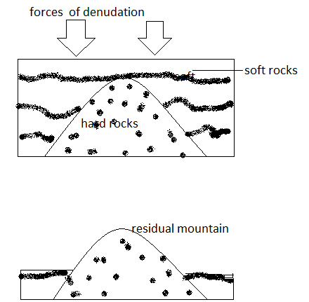
Existence of soft¹ and hard rocks¹ with the crust. Surface exposed to denudation forces¹. Soft rock wares out fast¹ leaving hard rock hanging above the surrounding areas¹ forming a residual mountain.
(6 marks)
c. (i) Promote Tourism
Encourage Transportation
Site for Fishing
Site for Electricity generation (2marks)
(ii)
A delta is a low-lying landform consisting mainly of sediments laid down by a river at its mouth while a flood plain is a flat area of land on either sides of the river which gets flooded periodical (2marks)

END OF QUESTION PAPER

